The BookChest Project

Agents of Change Project Proposal

January 8, 2016

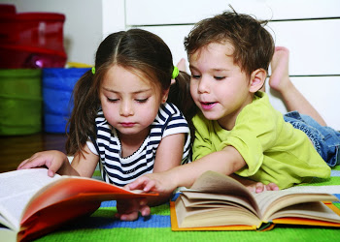

**Name**: Daniel Law

**Student Number**: 212202487

**Major**: Nursing

**Contact:** lawdanie@my.yorku.ca

Table of Contents

1. Executive Summary 1

2.0 Background Information2

2.1 Identification of Group Members……………………………...2

2.2 Identification of Community Partners…………………...2

2.3 Opportunity Statement…………………………………..2

3.0 Project Details……………………………………...3

3.1 Detailed Project Description……………………………..3

3.2 Evaluation & Success…………………………………….6

3.3 Sustainability……………………………………………..7

4.0 Supporting Documents9

**5.0 Budget………………………………………………12**

# 1.0 Executive Summary

The BookChest Project will be started to promote increased literacy and foster a love of reading in young children living in low-income neighbourhoods of Toronto. Reading is a necessary skill that is essential to our individual success in society; the ability to read is highly valued and important for future social, academic, and economic advancement. Canada is currently facing a literacy crisis; looking in Toronto, children in low-income neighbourhoods have consistently scored lower in the compulsory grade 10 literacy test compared to their more affluent counterparts. In addition to the direct link to future unemployment and poverty, illiterate Canadians lack the capacity to obtain, understand, and act upon health information conducive to making appropriate health decisions. This is an excellent opportunity for health promotion in young children utilizing a “grassroots” approach in low-income classrooms. The BookChest Project will provide free books in the unique form of a “BookChest” replete with additional reading resources. Delivering the books in the form of a gift is key because it reinforces the idea that they are receiving a present, and should be more motivated to enjoy reading the books. The founder of The BookChest Project will personally deliver the “BookChests” to classrooms and give a brief presentation on its contents, the importance of reading, and guidelines for setting up a school book club. This initiative will rely on working alongside Toronto District School Board staff, the Toronto Children’s Book Bank for its resources and experience, as well as “creative consultants” for its success. The target population will be students in grades 1 to 4 because this is the critical age range in cognitive development, and age-appropriate books will be properly curated. The BookChest Project will obtain new or gently used books from generous benefactors such as community organizations, libraries, public schools, religious institutions and publishers. Ultimately, The BookChest Project can be a sustainable endeavor that is flexible enough to operate throughout the school year, and funding will be primarily used for assembly and packaging of the “BookChests”.

# 2.0 Background Information

## 2.1 Identification of Group members

**Primary Group Contact:**

**Full Name**: Daniel Law

**Student Number**: 212202487

**Major/Program**: Nursing

**Email**: [lawdanie@my.yorku.ca](mailto:lawdanie@my.yorku.ca)

**Telephone**: 647-218-8967

## 2.2 Identification of Community Partners

To achieve The BookChest Project’s main vision of promoting literacy and fostering a love for reading, we have identified the Toronto Children’s Book Bank as the ideal community partner. Day-to-day operations involve providing free books and literacy support through their store located in the Rexdale neighbourhood. Their goal is to increase rates of book ownership and foster a love of reading in Toronto’s children which aligns with The BookChest Project’s vision. Furthermore, the Children’s Book Bank has experience distributing books to families who live too far away to visit. They routinely distribute free books to children in many of Toronto’s high-needs neighbourhoods including Parkdale, Jane & Finch, Weston, Lawrence Heights, Flemindon Park, Crescent Town and Malvern (Statistics Canada, 2011). Ultimately, the Children’s Book Bank will play a consultant role as The BookChest Project will rely on them for their expertise. In turn, The BookChest Project can promote the Children’s Book Bank’s services by including their pamphlets in our “BookChests”.

## 2.3 Opportunity Statement

A report from the Canadian Council on Learning warns of a literacy crisis brewing; adults with low literacy levels have increased health problems, earn less, and live shorter lives than other adults (CBC News, 2010). Furthermore, illiterate Canadians lack the capacity to obtain, understand and act upon health information and services conducive to making appropriate health decisions. Studies show that children from Toronto’s low-income neighbourhoods have increased difficulty with reading, and are at risk of academic difficulties. Children in low-income neighbourhoods have consistently scored lower in the compulsory grade 10 literacy test compared to their more affluent counterparts (Toronto Dominion Report, 2013). This downward spiral that starts at a young age predisposes an individual to poor health outcomes and a decreased level of wellbeing.

Reading at a young age has been shown to have multiple cognitive benefits including: academic excellence, basic speech and communication skills, mastery of language and vocabulary, increased logical thinking and creativity, and enhanced concentration and discipline. The BookChest Project can help encourage young children to read by 1) providing books and reading resources directly to low-income classrooms and 2) facilitating an increased enjoyment for reading at a young age.

Ultimately, this project will aim to promote health among young students by addressing the social determinants of education and early childhood development. The BookChest Project will collect new or gently used children’s books from community organizations, public schools, libraries, religious institutions and publishers. The books will then be packaged into an attractive “BookChest” which will be assembled with the help of a creative consultant. Once assembly is complete, The BookChest Project will contact classrooms in low-income neighbourhoods according to the After-Tax Low Income Measure map[1]. The BookChest Project will deliver the “BookChest” and also give a brief presentation to students. By taking this unique approach, The BookChest Project aims to have a long and sustainable impact on these children’s lives by 1) providing a much-needed supply of books and resources to their classroom libraries and 2) presenting the books in the form of a gift from benefactors, which will greatly increase their enjoyment and facilitate their motivation to read.

# 3.0 Project Details

## 3.1 Detailed Project Description

**Objectives & Goals**

The illiteracy rate is a prominent health issue that needs to be addressed in Toronto’s low-income neighbourhoods and schools. Community initiatives such as the Toronto Children’s Book Bank were started to combat this inequity, and there is an opportunity for The BookChest Project to help support the cause. The objective of this project is to provide books to classrooms in low-income neighbourhoods, and promote literacy by fostering a love of reading in these students starting at a young age. The initial goals for the summer of 2016 include:

1. Contacting potential donors and benefactors to collect 200 children’s books
2. In collaboration with a creative consultant, design and assemble two “BookChests” that includes books and reading resources
3. Arrange visits to two schools in identified low-income neighbourhoods starting with a pre-selected pilot-test classroom. Each visit includes delivery of a “BookChest” and a brief age-appropriate presentation on the contents of the “BookChest”, the benefits of reading, and how to start a book club at their school. If the program is well-received, visits to other schools can be arranged.

**Activities**

Identified donors will be contacted for book donations including: schools, libraries, religious institutions, community organizations and publishers. Many publishing houses donate books to non-profit organizations. The Children’s Book Bank will have a key role in this aspect, because they can provide contacts and guidance on how we can expand our book inventory. They have already suggested we contact the organization FirstBookCanada, which directly connects publishers looking to make book donations with programs such as this project that serve children in need.

Once the books are collected, they will be carefully sorted to ensure that only appropriate books are selected for the target population. Books that are unacceptable include: adult books or novels, young adult books or novels, educational textbooks, magazines, and damaged books. The BookChest Project will then work together with a creative consultant to design “BookChests” that are attractive and aesthetically pleasing for children; using a combination of paint, markers, and additional art supplies. “BookChests” can also have themes designed around the included books (i.e. a space-themed box for space books). The boxes will be large enough to hold a reasonable quantity of books along with additional resources[2]. “BookChests” will also include additional resources that contribute towards the goal of promoting literacy, such as a booklet on how students, teachers and parents can start a book club together. A book club is an excellent way of getting the school and community involved in developing children’s love for books. Also included is a “book tracker” that can be posted on a classroom wall; it helps track how many books each student has read over time, and in turn rewards can be given out as incentives to read. A package of bookmarks will also be included in the box as gifts for the teachers to distribute. As a promotional service, pamphlets from the Children’s Book Bank will also be placed into the boxes. Once the “BookChests” have been assembled, The BookChest Project will contact schools in low-income neighbourhoods to assess their classroom’s needs for books, establish rapport with staff, and pitch the opportunity.

Necessary preparations prior to the classroom visit include: arranging transportation of the “BookChest”, having a valid police check, scheduling a presentation date, and informing the homeroom teacher what to expect from The BookChest Project’s visit. Once arranged with the homeroom teacher, a visit from The BookChest Project includes personal delivery of the “BookChest” and a brief 10-15 minute PowerPoint presentation. The presentation will include age-appropriate information on the benefits of reading, a summary of the contents of the “BookChest”, where the books came from, and instructions on how to get a book club started at their school. By turning the delivery of the “BookChest” into this mini-event, it will raise awareness within the school of the importance of literacy. After the first pilot visit, the project will be evaluated using feedback from the homeroom teacher to assess if the project’s quality can be improved before the next visit. Although a classroom visit is ambitious, the founder of The BookChest Project has experience running presentations on various topics to young students in the target age range.

**Pilot Program – Rene Gordon Elementary School**

For the pilot test, The BookChest Project has selected Rene Gordon Elementary School located at Don Mills & York Mills. The founder has prior connections with the principal, Jeff Little, through a nursing co-op placement. Rene Gordon is located in the Parkwoods Donalda neighbourhood, where 20% of residents are classified under the After-Tax Low Income Measure category[3]. The project’s details have been pitched to Jeff and he is extremely receptive to the idea. Through Jeff, The BookChest Project has established contact with the grade 4 homeroom teacher, Ms. Mohan, who is also receptive to the project and is willing to schedule a classroom visit in May when The BookChest Project is ready to deliver[4]. After a brief discussion, The BookChest Project has learned that Ms. Mohan’s classroom is in short supply of books and most of her students are from immigrant backgrounds. These factors make her class the ideal case to pilot-test the project, and feedback will be obtained from Ms. Mohan after project implementation.

**Key Personnel:**

**Daniel Law:** Primary contact and founder of the The BookChest Project initiative. His tasks for the project will include contacting donors for books, overseeing the assembly of the “BookChests”, arranging visits to schools, delivering “the BookChests”, giving presentations to classes, and evaluating the program’s success.

**Thomas Ng**: Graduate of Sheridan College’s Illustration undergraduate program. He will be the creative consultant behind the design and assembly of the “BookChests” for the children. With input from the founder, Thomas will have creative freedom in designing the boxes.

Email: [tom@tknson.com](mailto:tom@tknson.com)

Website: http://www.tknson.com/

**Jeff Little**: The founder of The BookChest Project already has an established relationship with the principal of Rene Gordon Elementary, a school in the Toronto District School Board. The project has been pitched to Principal Little and he is very receptive to the idea of receiving a “BookChest” and a visit. Rene Gordon is located in a low-income neighbourhood according to Toronto’s neighbourhood profiles. Considering these factors, this makes Rene Gordon an ideal school for a pilot-test visit. Principal Little will also be a valuable partner because of his connections with other TDSB schools, and his community partnerships with book organizations and libraries.

Email: [jeff.little@tdsb.on.ca](mailto:jeff.little@tdsb.on.ca)

Website: http://schoolweb.tdsb.on.ca/renegordon/Home.aspx

**Roxanne Deans:** The primary contact from the Children’s Book Bank is Roxanne Deans, the Director of Inventory and Outreach. The BookChest Project has established contact with Ms. Deans and she has expressed her support for the project. She has suggested other partnerships such as FirstBookCanada for expanding our inventory. Ms. Deans is also willing to be a consultant to The BookChest Project; offering advice and experience on how to approach potential donors for book donations.

Email: [roxanne.deans@childrensbookbank.com](mailto:roxanne.deans@childrensbookbank.com) Website: <http://www.childrensbookbank.com/>

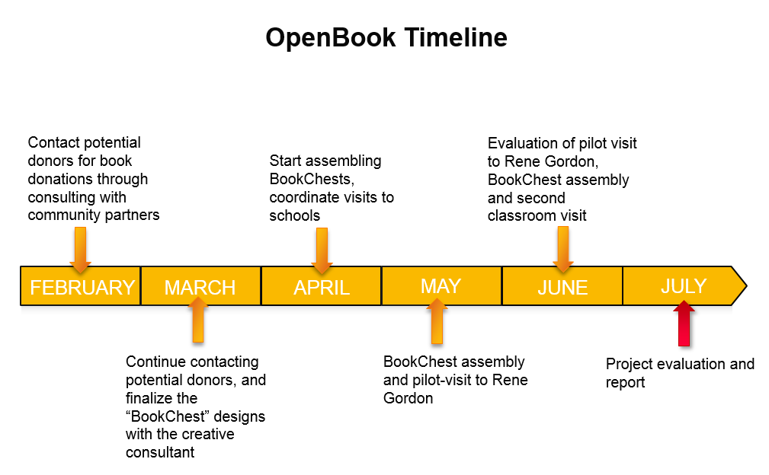

## 3.2 Evaluation & Success

The primary method of evaluation for The BookChest Project’s success will be based on feedback obtained from students, teachers and parents. After the classroom visit, we will have an informal discussion with teachers regarding what they liked about the visits, the information that was conveyed in the presentations, and if anything can be improved upon. The BookChest Project will then follow up with the classes one month later to find out if the students enjoy reading the donated books, and track their progress on starting up their book club. The BookChest Project will also provide a short survey for the teacher to distribute to parents inquiring whether their child’s reading habits have changed, or if they’ve mentioned they enjoy reading more.

## 3.3 Sustainability

When implementing any type of initiative such as The BookChest Project, sustainability is of utmost importance. The project should have a lasting impact so it can continue to raise awareness for literacy among young students in low-income neighbourhoods. The main aspect of The BookChest Project to achieve this goal are the additional resources provided in the “BookChests” such as the booklet for students and teachers on starting book clubs. By “planting” book clubs in these schools, The BookChest Project aims to have a long and sustainable impact in the local community by initiating discussions among students, teachers and parents to cultivate children’s love for reading. Once The BookChest Project has accomplished its goals for the summer of 2016 and received positive feedback, it will demonstrate that the project has tangible benefits and potential benefactors or sponsors can be approached for grants or donations.

References

Low-literacy adults to increase 25% by 2031: report. (2010, September 8). *CBC News.* Retrieved from:

<http://www.cbc.ca/news/canada/low-literacy-adults-to-increase-25-by-2031-report-1.866332>

Statistics Canada. (2011). City of Toronto Neighbourhood Profiles: Retrieved from:

<http://www1.toronto.ca/wps/portal/contentonly?vgnextoid=ae17962c8c3f0410VgnVCM>

0000071d60f89RCRD

Statistics Canada. (2011). City of Toronto Neighbourhood Profiles: Parkwoods-Donalda (45). Retrieved from:

<http://www1.toronto.ca/wps/portal/contentonly?vgnextoid=3b4cc91a1ccd1410VgnVCM>

10000071d60f89RCRD&vgnextchannel=1e68f40f9aae0410VgnVCM10000071d60f89RCRD

Toronto Dominion. (2013). Canada’s Literacy and Numeracy Challenge Worsens: Special Report. Retrieved from:

<https://www.td.com/document/PDF/economics/special/CanadaLiteracyAndNumeracyChallengeWorsens>.p

df

# 4.0 Supporting Documents



Low-Income Persons According to the After-Tax Low Income Measure. (2009). Retrieved from: http://www.torontohealthprofiles.ca/a_dataTables.php?varTab=HPDtbl



Rene Gordon Neighbourhood Profile. Retrieved from: http://www1.toronto.ca/wps/portal/contentonly?vgnextoid=ae17962c8c3f0410VgnVCM10000071d60f89RCRD

**Preliminary “BookChest” Designs**

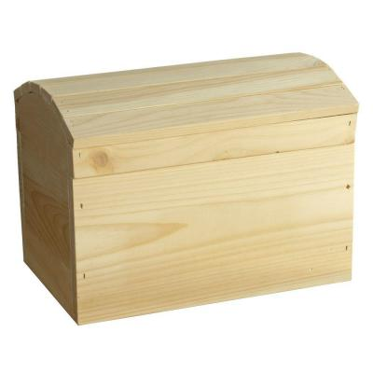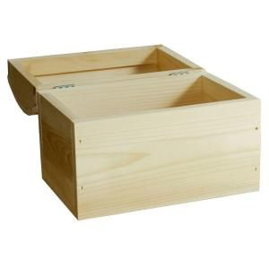

Box dimensions (in.):   
Height: 9   
Width: 14  
Height: 10

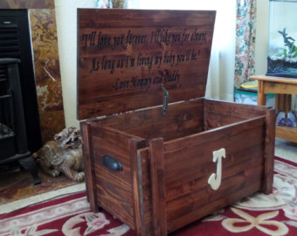

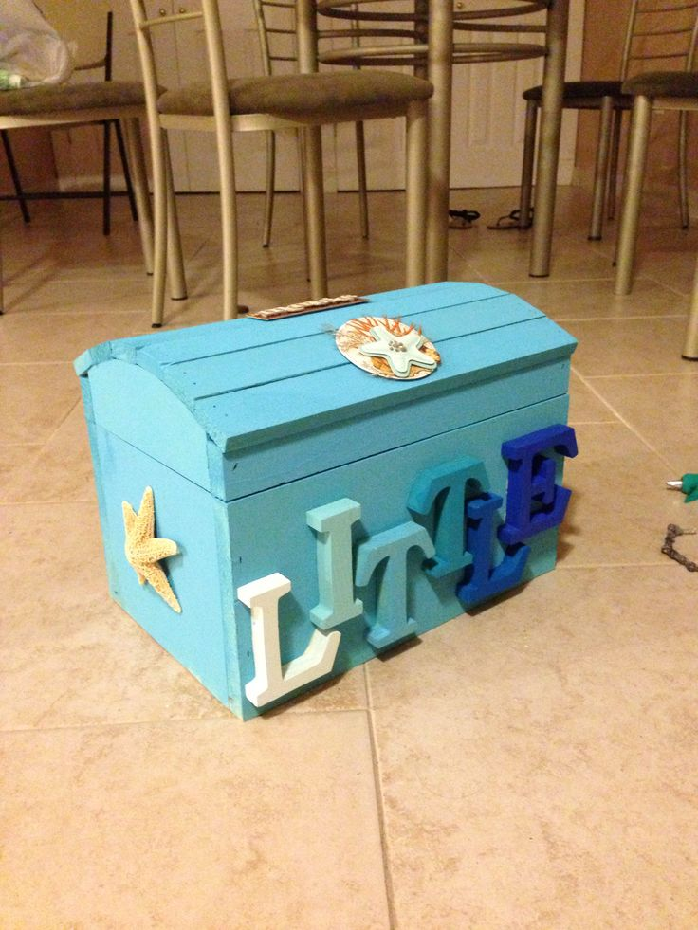 

|  |  |  |  |  |  |  |
| --- | --- | --- | --- | --- | --- | --- |
| **Task/Activity**  *Write down the overall activity.* | **Detailed Cost**  *Break down the activity in terms of components and their costs.* | **Personnel**  *Who is responsible for this task (if applicable)* | **In-Kind Funding**  *Here you can attach a value to your time, or to other donations you have received.* | **Secure Funding**  *Use this column to display outside funds you have already secured for your project.* | **Agents of Change Funding**  *Use this column to indicate the funds which you are requesting from the Faculty of Health.* | **Total**  *Display the total costs here.* |
| Assembly and packaging of book “BookChests” | 2 plain wooden chests at $30.00/chest |  |  |  | $60.00 | $60.00 |
| Art supplies (paint, markers) at $40.00 |  |  |  | $40.00 | $40.00 |
| 60 bookmarks at $20.00 |  |  |  | $20.00 | $20.00 |
| 8 hours of labour (design, painting of boxes) at $15/hr | Thomas Ng (creative consultant) | $120.00 |  |  | $120.00 |
|  | Printing services for booklets at $10/booklet |  |  |  | $20.00 | $20.00 |
| **Total** |  |  | $120.00 |  | $140.00 | $360.00 |

# 5.0 Project Budget

1. See supporting documents, page 9
2. Preliminary designs for the boxes are included in the supporting documents, page 10 for reference.
3. See supporting documents page 10
4. See timeline page 6